Lab#8 SORTING ALGORITHMS LAB
Understanding Selection Sort, Insertion Sort, and Quick Sort

Lab Exercises

Exercise 1: Implementation
Implement all three sorting algorithms in Python. Test them with the following arrays:
- [64, 25, 12, 22, 11]
- [1, 2, 3, 4, 5] (already sorted)
- [5, 4, 3, 2, 1] (reverse sorted)
Program:

#include <iostream>
using namespace std;

void bubble(int a[], int n) {
for (int i = 0; i < n; i++) {
for (int j = 0; j < n - 1; j++) {
if (a[j] > a[j + 1]) {
int temp = a[j];
a[j] = a[j + 1];
a[j + 1] = temp;
}
}
}
}

void selection(int a[], int n) {
for (int i = 0; i < n; i++) {
int min = i;
for (int j = i + 1; j < n; j++) {
if (a[j] < a[min]) {
min = j;
}
}
int temp = a[i];
a[i] = a[min];
a[min] = temp;
}
}

void insertion(int a[], int n) {
for (int i = 1; i < n; i++) {
int key = a[i];
int j = i - 1;
while (j >= 0 && a[j] > key) {
a[j + 1] = a[j];
j--;
}
a[j + 1] = key;
}
}

void print(int a[], int n) {
for (int i = 0; i < n; i++) {
cout << a[i] << " ";
}
cout << endl;
}

int main() {
int arr1[] = { 64,25,12,22,11 };
int arr2[] = { 1,2,3,4,5 };
int arr3[] = { 5,4,3,2,1 };
int n = 5;

cout << "Bubble: ";
bubble(arr1, n);
print(arr1, n);

cout << "Selection: ";
selection(arr2, n);
print(arr2, n);

cout << "Insertion: ";
insertion(arr3, n);
print(arr3, n);

return 0;
}
Output: 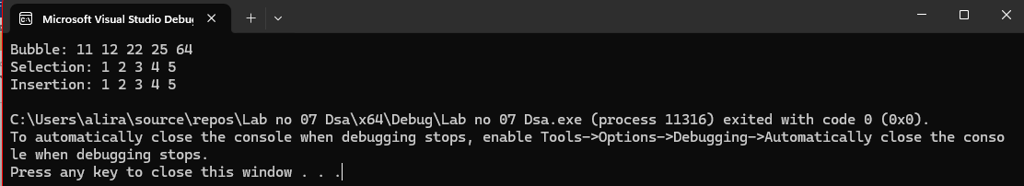

Exercise 2: Performance Analysis
Measure the execution time for each algorithm with arrays of different sizes: 100, 500, 1000, 2000, 3000 elements.
Create a graph showing the performance comparison.
Program:
#include <iostream>
using namespace std;

int bubble(int a[], int n) {
int count = 0;
for (int i = 0; i < n; i++) {
for (int j = 0; j < n - 1; j++) {
count++;
if (a[j] > a[j + 1]) {
int temp = a[j];
a[j] = a[j + 1];
a[j + 1] = temp;
}
}
}
return count;
}

int selection(int a[], int n) {
int count = 0;
for (int i = 0; i < n; i++) {
int min = i;
for (int j = i + 1; j < n; j++) {
count++;
if (a[j] < a[min]) {
min = j;
}
}
int temp = a[i];
a[i] = a[min];
a[min] = temp;
}
return count;
}

int insertion(int a[], int n) {
int count = 0;
for (int i = 1; i < n; i++) {
int key = a[i];
int j = i - 1;
while (j >= 0 && a[j] > key) {
count++;
a[j + 1] = a[j];
j--;
}
a[j + 1] = key;
}
return count;
}

void copy(int a[], int b[], int n) {
for (int i = 0; i < n; i++) b[i] = a[i];
}
int main() {
int sizes[] = { 100,500,1000,2030,3200 };

cout << "Size\tBubble\tSelection\tInsertion\n";

for (int s = 0; s < 5; s++) {
int n = sizes[s];

int* arr = new int[n];
int* temp = new int[n];

for (int i = 0; i < n; i++) {
arr[i] = n - i;
}

int b = bubble(arr, n);

copy(arr, temp, n);
int sel = selection(temp, n);

copy(arr, temp, n);
int ins = insertion(temp, n);

cout << n << "\t" << b << "\t" << sel << "\t" << ins << endl;

delete[] arr;
delete[] temp;
}

return 0;
}

Output:
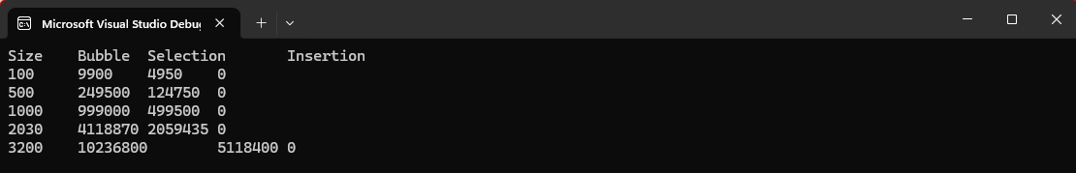

Exercise 3: Counting Operations
Modify each algorithm to count the number of comparisons and swaps. Record these values for different input sizes and verify they match the theoretical complexity.
Hint: Add counter variables and increment them at comparison and swap points.
Program:
#include <iostream>
using namespace std;

void bubble(int a[], int n) {
int c = 0, s = 0;
for (int i = 0; i < n; i++) {
for (int j = 0; j < n - 1; j++) {
c++;
if (a[j] > a[j + 1]) {
int t = a[j]; a[j] = a[j + 1]; a[j + 1] = t;
s++;
}
}
}
cout << "Bubble: C=" << c << " S=" << s << endl;
}
void selection(int a[], int n) {
int c = 0, s = 0;
for (int i = 0; i < n; i++) {
int min = i;
for (int j = i + 1; j < n; j++) {
c++;
if (a[j] < a[min]) min = j;
}
int t = a[i]; a[i] = a[min]; a[min] = t;
s++;
}
cout << "Selection: C=" << c << " S=" << s << endl;
}

void insertion(int a[], int n) {
int c = 0, s = 0;
for (int i = 1; i < n; i++) {
int key = a[i], j = i - 1;
while (j >= 0 && a[j] > key) {
c++;
a[j + 1] = a[j];
s++;
j--;
}
a[j + 1] = key;
}
cout << "Insertion: C=" << c << " S=" << s << endl;
}

int main() {
int a[] = { 64,25,12,22,11 };
int b[] = { 1,2,3,4,5 };
int c[] = { 5,4,3,2,1 };
int n = 5;

bubble(a, n);
selection(b, n);
insertion(c, n);

return 0;
}
Output:
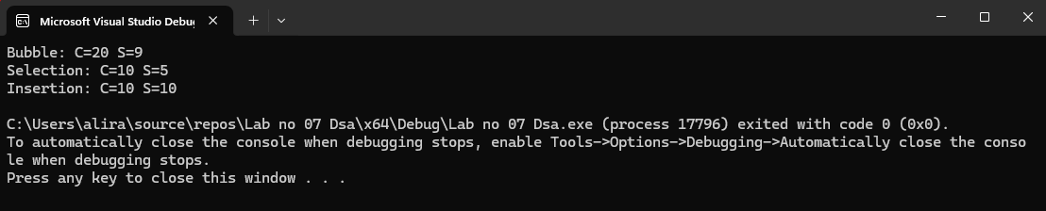

Exercise 4: Challenge
Modify the Quick Sort implementation to use different pivot selection strategies (first element, middle element, random element). Compare their performance.
Program:
#include <iostream>
using namespace std;

void swap(int& a, int& b) {
int t = a; a = b; b = t;
}

int partition(int a[], int low, int high) {
int pivot = a[high];
int i = low - 1;

for (int j = low; j < high; j++) {
if (a[j] < pivot) {
i++;
swap(a[i], a[j]);
}
}
swap(a[i + 1], a[high]);
return i + 1;
}

void quickSort(int a[], int low, int high) {
if (low < high) {
int pi = partition(a, low, high);
quickSort(a, low, pi - 1);
quickSort(a, pi + 1, high);
}
}

int main() {
int arr1[] = { 64,5,12,22,11 };
int arr2[] = { 4,25,12,2,1 };
int arr3[] = { 64,2,12,22,11 };
int n = 5;

swap(arr1[0], arr1[n - 1]);
quickSort(arr1, 0, n - 1);
cout << "First pivot: ";
for (int i = 0; i < n; i++) cout << arr1[i] << " ";
cout << endl;

swap(arr2[n / 2], arr2[n - 1]);
quickSort(arr2, 0, n - 1);
cout << "Middle pivot: ";
for (int i = 0; i < n; i++) cout << arr2[i] << " ";
cout << endl;
swap(arr3[1], arr3[n - 1]);
quickSort(arr3, 0, n - 1);
cout << "Random pivot: ";
for (int i = 0; i < n; i++) cout << arr3[i] << " ";
cout << endl;

return 0;
}
Output:
